Log in to AWS and go to services > S3

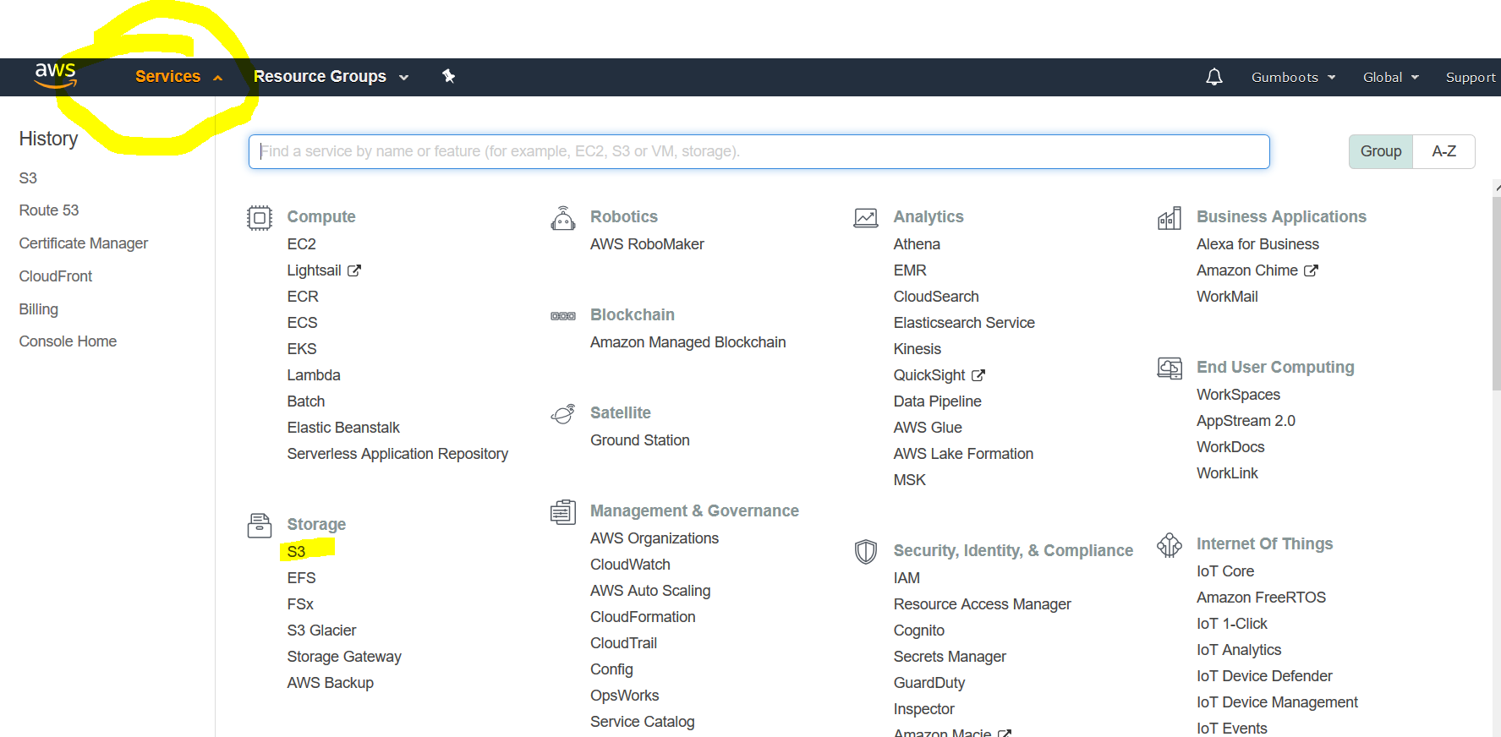

Open your bucket called [www.gumbootsconsultingengineers.co.nz](http://www.gumbootsconsultingengineers.co.nz)

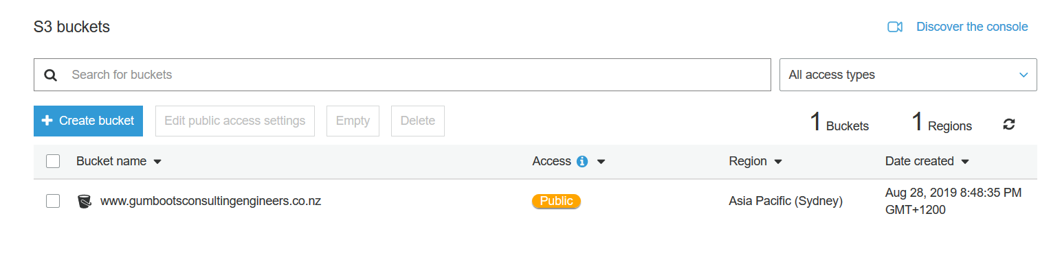

Home is the home page, note it has no extension, this is on purpose to make your url look clean (e.g. [www.gumbootsconsultingengineers.co.nz](http://www.gumbootsconsultingengineers.co.nz) instead of [www.gumbootsconsultingengineers.co.nz/home.html](http://www.gumbootsconsultingengineers.co.nz/home.html)

Img is your images folder.

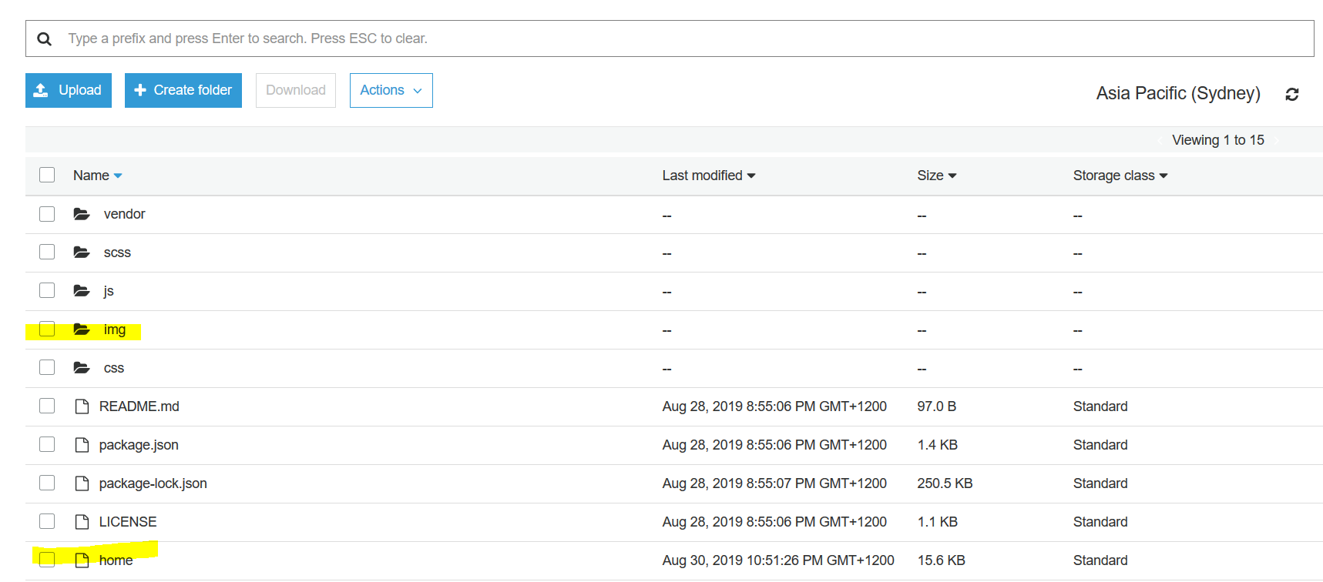

Download a copy of home to your computer and use this to make changes to the text in your website. Rename it to home.html and open with a text viewer (I recommend ‘visual studio code’ which will make it easy to read).

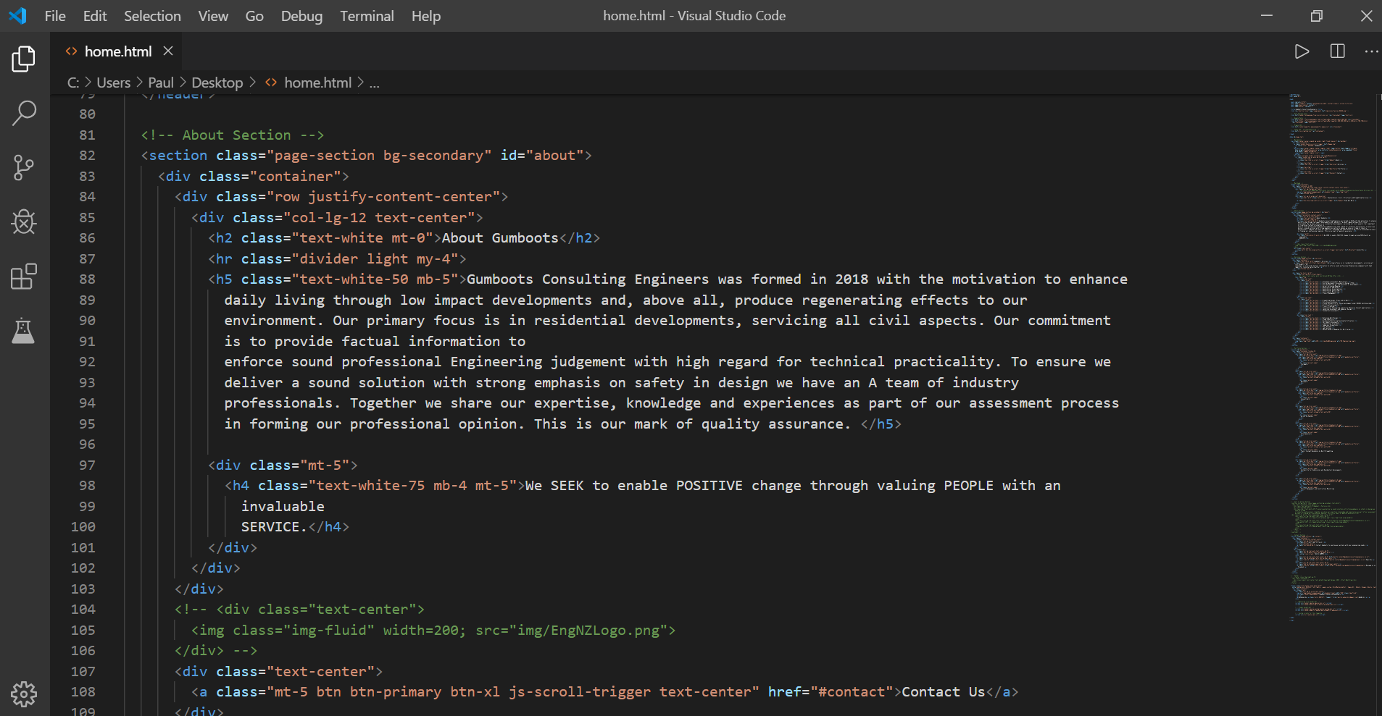

Before you change anything backup the home file so if you stuff up you can just copy it back into the bucket and go back to where you started.

You can then change the text, save it, rename to ‘home’ and then copy into the bucket to make the changes live.

Changing images – You will see in home images referenced like this



If you upload a new file into the directory in the s3 bucket e.g. img/portfolio/thumbnails/ and you can either call it image 1.jpg and rename the original, or change the file name above in the home file to the new image name. e.g.

<a class="portfolio-box" href="img/portfolio/thumbnails/new1.jpg">

<img class="img-fluid" src="img/portfolio/thumbnails/new1.jpg" alt="gumboots portfolio">